DS-2CD1123G0-I
2.0 MP IR Network Dome Camera

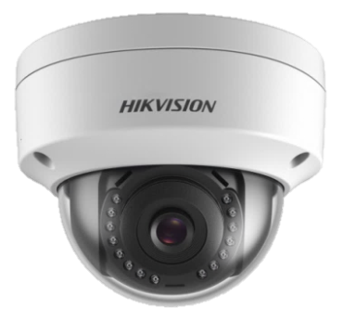 | 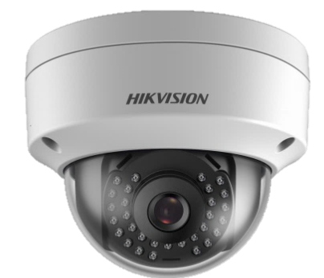
2.8 mm Fixed Lens | Non 2.8 mm Fixed Lens

Key Features

- 1/2.8" progressive scan CMOS | - 3D DNR (Digital Noise Reduction)
- 1920 × 1080@30fps | - Up to 30 m IR range
- 2.8 mm/4 mm/6 mm fixed lens | - PoE (Power over Ethernet)
- H.265+, H.265, H.264+, H.264 | - IP67, IK10
- Dual stream
- Digital WDR (Wide Dynamic Range)

Camera
Specification
Image Sensor | 1/2.8" progressive scan CMOS
Min. Illumination | Color: 0.01 Lux @(F1.2, AGC ON), 0.028Lux @ (F2.0, AGC ON)
Shutter Speed | 1/3 s to 1/100, 000 s
Slow Shutter | Yes
Auto-Iris | No
Day &Night | IR cut filter
Digital Noise Reduction | 3D DNR
WDR | Digital WDR
Angle Adjustment | Pan: 0° to 355°, tilt: 0° to 70°
Lens
Focal length | 2.8 mm, 4 mm, 6 mm
Aperture | F2.0
Focus | No
FOV | 2.8 mm, horizontal FOV 114°, vertical FOV 62°, diagonal FOV 135°  4 mm, horizontal FOV 86°, vertical FOV 46°, diagonal FOV 102°  6 mm, horizontal FOV 54°, vertical FOV 30°, diagonal FOV 62°
Lens Mount | M12
IR
IR Range | Up to 30 m
Wavelength | 850 nm
Compression Standard
Video Compression | Main stream: H.265/H.264  Sub stream: H.265/H.264/MJPEG
H.264 Type | Baseline Profile/Main Profile/High Profile
H.264+ | Main stream supports
H.265 Type | Main Profile
H.265+ | Main stream supports
Video Bit Rate | 32 Kbps to 8 Mbps
Smart Feature-set
Region of Interest | 1 fixed region for main stream and sub-stream
Image
Max. Resolution | 1920 × 1080
Main Stream  Max. Frame Rate | 50Hz: 25fps (1920 × 1080, 1280 × 960, 1280 × 720)  60Hz: 30fps (1920 × 1080, 1280 × 960, 1280 × 720)
Sub-stream  Max. Frame Rate | 50Hz: 25fps (640 × 480, 640 × 360, 320 × 240)  60Hz: 30fps (640 × 480, 640 × 360, 320 × 240)
Image Enhancement | BLC, 3D DNR
Image Setting | Saturation, brightness, contrast, sharpness, AGC, white balance adjustable by client software or web browser
Day/Night Switch | Auto, scheduled
Network
Alarm Trigger | Motion detection, video tampering alarm, illegal login
Protocols | TCP/IP, ICMP, HTTP, HTTPS, FTP, DHCP, DNS, DDNS, RTP, RTSP, RTCP, NTP, UPnP, SMTP, IGMP, 802.1X, QoS, IPv6, UDP, Bonjour
General Function | Anti-flicker, heartbeat, mirror, password protection, privacy mask, watermark
Firmware Version | 5.5.2
API | ONVIF (PROFILE S, PROFILE G), ISAPI
Simultaneous Live View | Up to 6 channels
User/Host | Up to 32 users  3 levels: Administrator, Operator, and User
Client | iVMS-4200, Hik-Connect, iVMS-5200
Web Browser | IIE7+, Chrome18-42, Firefox5.0+, Safari5.02+
Interface
Communication Interface | 1 RJ45 10M/100M self-adaptive Ethernet port
General
Operating Conditions | -30 °C to 50 °C (-22 °F to 122 °F), humidity: 95% or less (non-condensing)
Power Supply | 12 VDC ± 25%, 5.5 mm coaxial power plug  PoE (802.3af, class 3)
Power Consumption and Current | 12 VDC, 0.4 A, Max: 5 W  PoE: (802.3af, 37 V to 57 V), 0.2 A to 0.13 A, Max: 7 W
Ingress Protection | IP67, IK10  TVS 2000V lightning protection, surge protection and voltage transient protection
Material | Metal & Plastic
Dimensions | Camera: Ø 111 mm × 82.4 mm ( 4.4" × 3.2")  With package: 134 mm × 134 mm × 108 mm (5.3" × 5.3" × 4.3")
Weight | Camera: Approx. 410 g (0.9 lb.)  With package: Approx. 610 g (1.3 lb.)

Available Models
DS-2CD1123G0-I (2.8 mm), DS-2CD1123G0-I (4 mm), DS-2CD1123G0-I (6 mm)

Dimension
Accessory
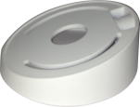  DS-1259ZJ  Inclined Base Mounting Bracket | 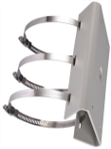  DS-1275ZJ-SUS  Vertical Pole Mount | 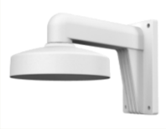  DS-1273ZJ-135  Wall Mount | 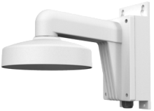  DS-1273ZJ-135B  Wall Mount
DS-1271ZJ-135  Pendant Mount | 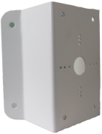  DS-1276ZJ-SUS  Corner Mount | 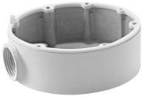  DS-1280ZJ-DM21  Junction Box | 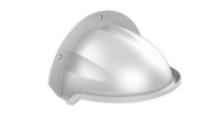  DS-1250ZJ  Rain Shade

050520180120

050520170918

050440161122

